SIGN LANGUAGE RECOGNITION SYSTEM BASED ON CONVOLUTIONAL NEURAL NETWORKS (CNNS)
Block Diagrams (all)
Department of Computer Science and Engineering, TKR College of Engineering & Technology
Batch A16 (CSE-A) · Academic year [ACADEMIC YEAR]
Table 1: Project team
S.No. | Student name | Roll number
1 | AJAY | 24K95A0502
2 | A NAVADEEP REDDDY | 23K91A0514
3 | B MANIDEEP | 23K91A0540
4 | B MAHESHWARI | 23K91A0536

Project guide: V. PALLAVI
Chapter and section numbers quoted in the text (for example Chapter 8 or Section 6.2) refer to the full project report, 17.Final Document. Figures and tables in this document are numbered from 1.

1. INDEX OF DIAGRAMS
Every diagram was generated from the real design by scripts/docs_build/make_diagrams.py and diagrams_more.py (matplotlib, 150 dpi) and mirrors the code in backend/main.py and sign_language_app/. SignSpeak has no SQL database, so the entity-relationship diagram shows the file-system data model.
Table 2: Diagrams in this document
No. | Diagram | Image file
1 | System architecture | docs/diagrams/01_system_architecture.png
2 | High-level workflow | docs/diagrams/02_high_level_workflow.png
3 | Data flow diagram, level 0 (context) | docs/diagrams/03_dfd_level0.png
4 | Data flow diagram, level 1 | docs/diagrams/04_dfd_level1.png
5 | Data flow diagram, level 2 (process 3.0) | docs/diagrams/05_dfd_level2.png
6 | UML class diagram | docs/diagrams/06_class_diagram.png
7 | Sequence diagram: live recognition | docs/diagrams/07_sequence_recognition.png
8 | Use case diagram | docs/diagrams/08_use_case.png
9 | Entity-relationship diagram (file store) | docs/diagrams/09_er_diagram.png
10 | Flowchart of the core algorithm | docs/diagrams/10_core_algorithm_flowchart.png
11 | CNN architecture | docs/diagrams/11_cnn_architecture.png
12 | Training pipeline | docs/diagrams/12_training_pipeline.png

2. DIAGRAMS

System architecture
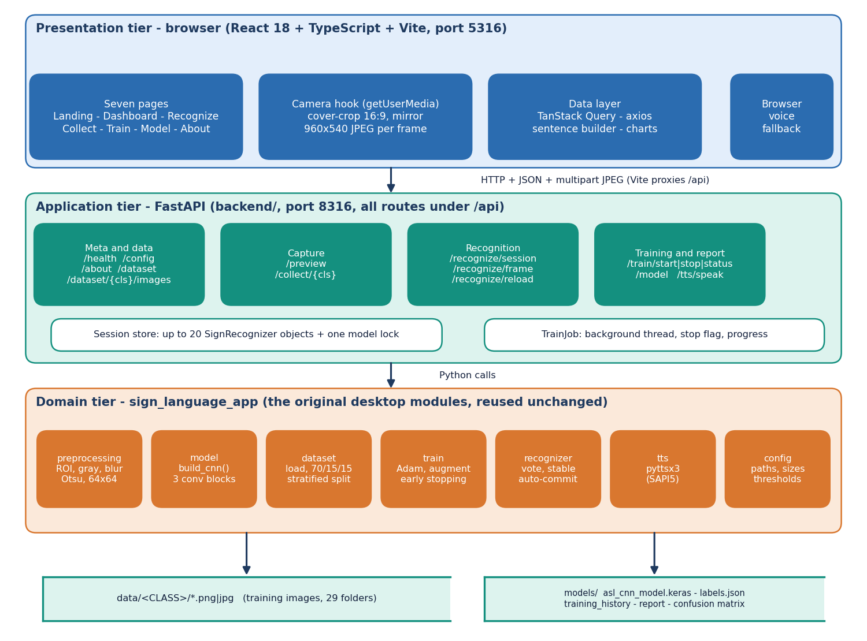
Figure 1: System architecture of SignSpeak: presentation, application and domain tiers with the two file stores.
The system has three tiers over two stores. The presentation tier is a React 18 + TypeScript application served by Vite on port 5316; it owns the webcam through the browser's getUserMedia call, cover-crops each frame to 16:9, mirrors it and uploads it as a 960x540 JPEG. The application tier is a thin FastAPI service on port 8316 (backend/): 16 endpoints under /api, a store of at most 20 recognition sessions, one lock around the Keras model and a background training thread. The domain tier is the original desktop application's package sign_language_app (preprocessing, model, dataset, train, recognizer, tts, config), reused unchanged, so the web and desktop versions cannot drift apart. Training images are kept in data/<CLASS>/ and the trained model with its reports in models/. There is no SQL database.

High-level workflow
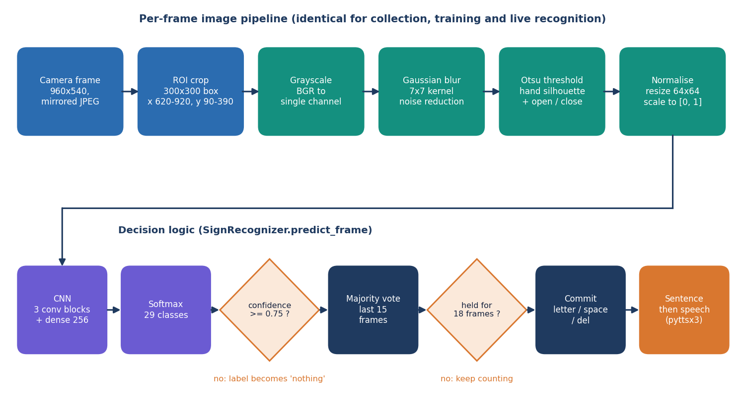
Figure 2: High-level workflow from image collection to spoken sentence.
The workflow has two halves. The offline half gathers labelled hand images (own captures in the Collect screen or the public ASL Alphabet set), preprocesses them with the same pipeline used at run time, trains the CNN with augmentation and early stopping, evaluates it on a held-out split and stores the model with its reports. The online half starts the camera, sends frames to the recogniser, smooths the predictions, appends a letter to the sentence when a sign has been held steadily, and speaks the sentence on request. Training and recognition share one preprocessing function, which removes a common source of train/serve mismatch.

Data flow diagram, level 0 (context)
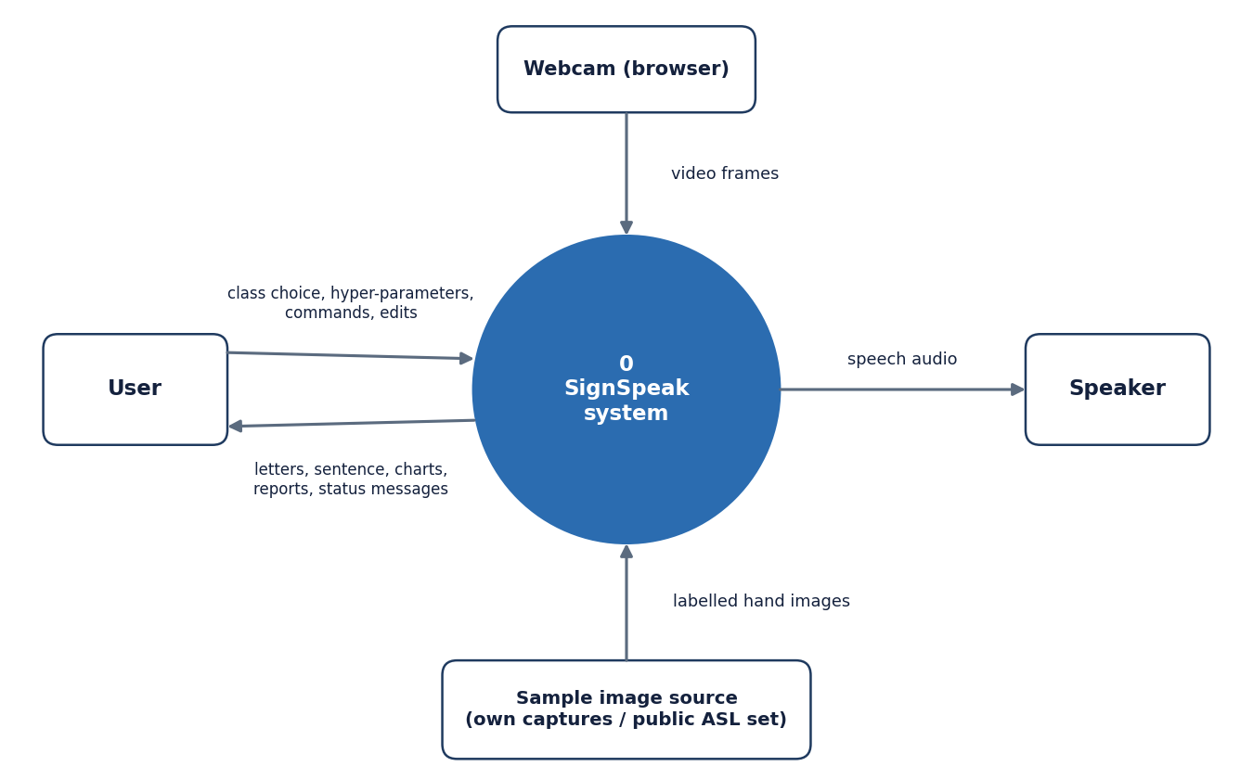
Figure 3: Level 0 data flow diagram: SignSpeak as a single process with four external entities.
At the context level SignSpeak is one process. The user supplies class choices, hyper-parameters and commands and receives letters, the sentence, charts, reports and status messages. The browser webcam supplies video frames. A sample-image source (the user's own captures or the public ASL Alphabet images) supplies labelled hand images. The speaker receives synthesised speech.

Data flow diagram, level 1
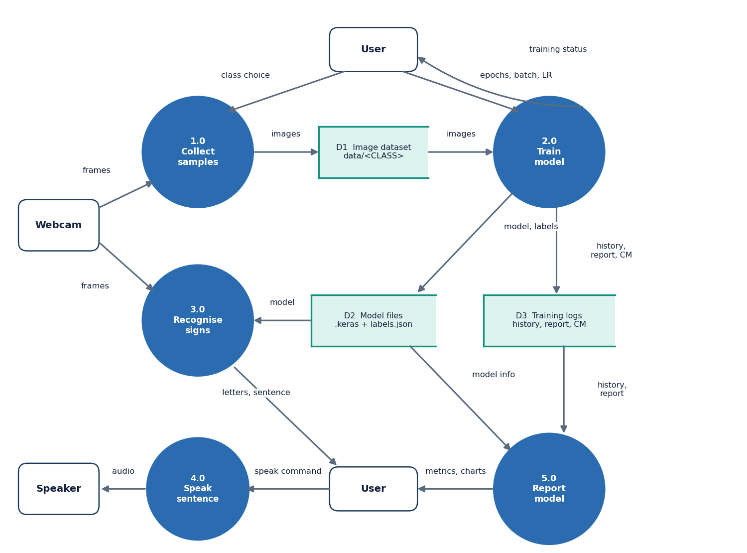
Figure 4: Level 1 data flow diagram: five processes and three data stores.
Level 1 splits the system into five processes: 1.0 Collect samples (frames in, images to store D1), 2.0 Train model (images from D1, hyper-parameters from the user; writes the model to D2 and history, report and confusion matrix to D3), 3.0 Recognise signs (frames and the model in; letters and the sentence out), 4.0 Speak sentence (text to the speaker) and 5.0 Report model (history and report from D3, model information from D2, charts to the user). D1 is the image dataset, D2 the model files and D3 the training logs. The user appears twice only to keep the arrows from crossing.

Data flow diagram, level 2 (process 3.0)
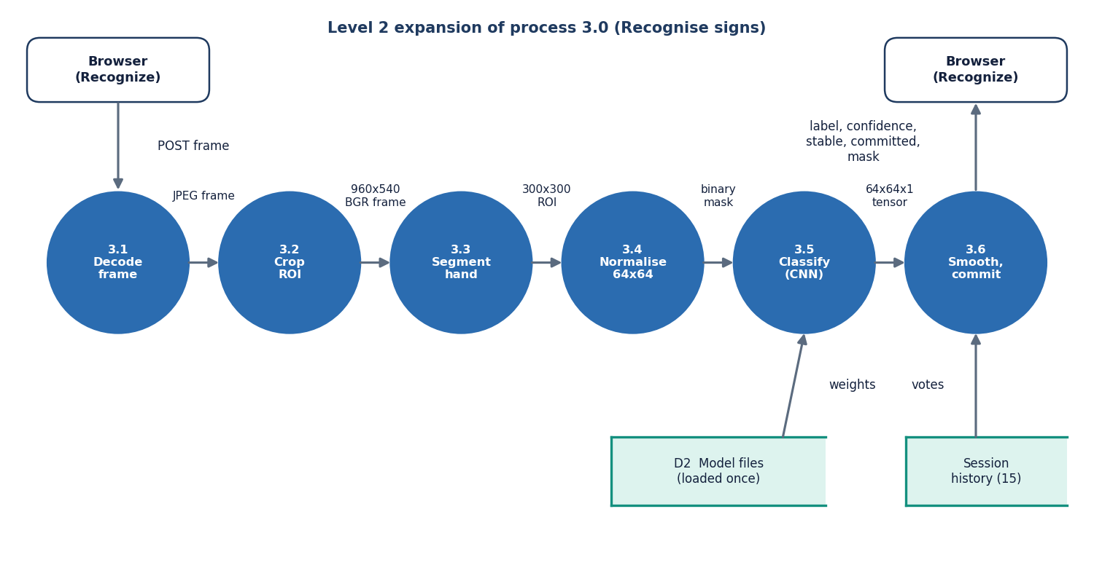
Figure 5: Level 2 data flow diagram: the six steps inside process 3.0, Recognise signs.
Process 3.0 expands into six steps that mirror SignRecognizer.predict_frame: 3.1 decode the JPEG frame, 3.2 crop the 300x300 region of interest, 3.3 segment the hand (grayscale, blur, Otsu threshold, morphology), 3.4 normalise to a 64x64 tensor, 3.5 classify with the CNN loaded once from D2, and 3.6 smooth the result with the session's history of 15 votes and decide whether to commit a letter. The result returned to the browser holds the label, its confidence, the stable label, the committed letter and the mask image.

UML class diagram
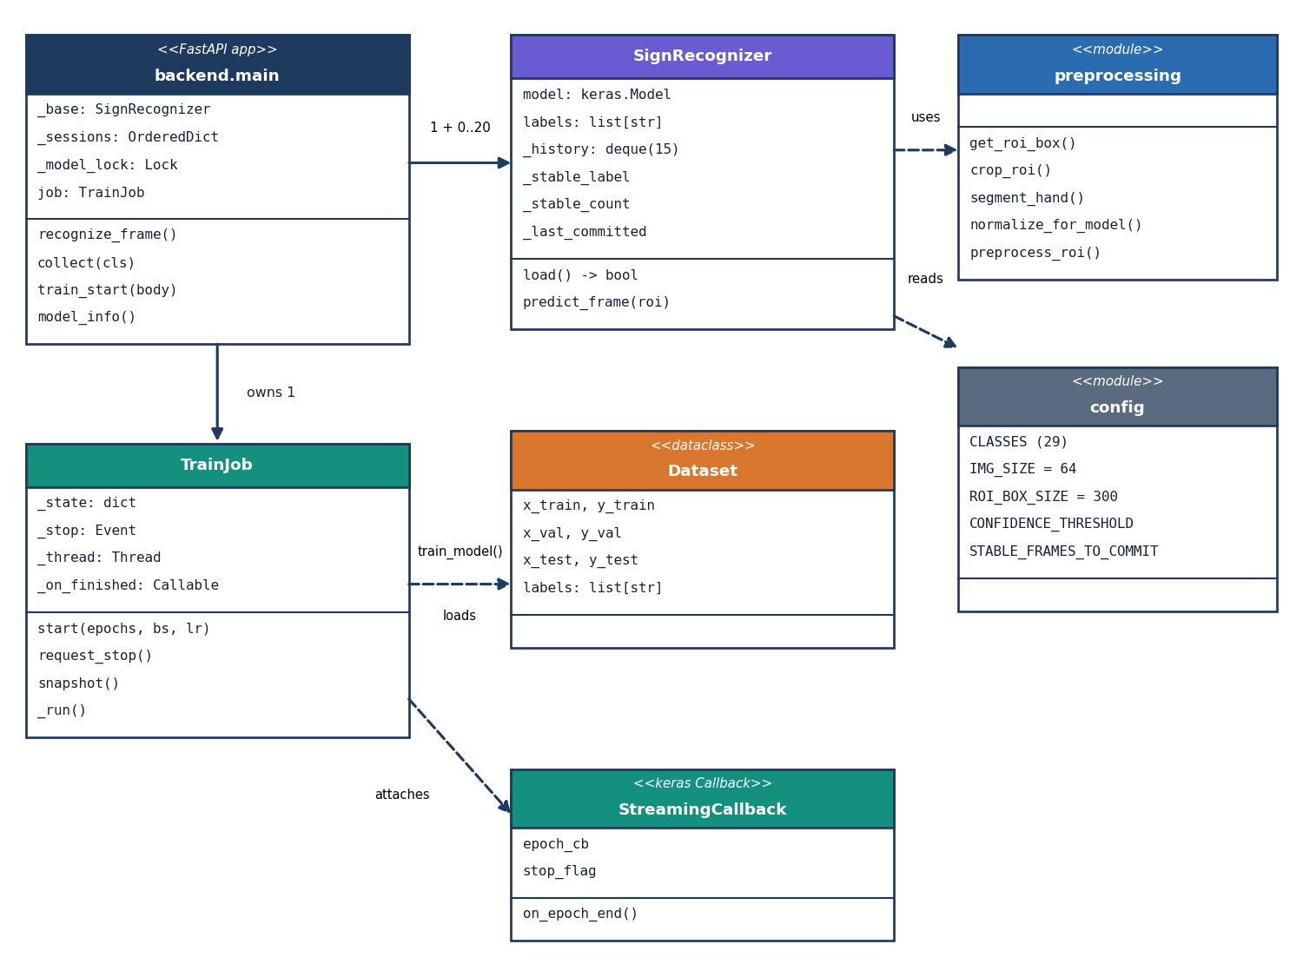
Figure 6: UML class diagram of the main classes and modules.
The code base is mostly modules of functions, so the diagram shows the real classes and the modules they use. backend.main owns one base SignRecognizer (which holds the Keras model), up to 20 per-session recognisers that share its model and labels, a model lock and a TrainJob. TrainJob runs train_model on a thread; the training code loads a Dataset dataclass (train, validation and test arrays plus the label list) and attaches a StreamingCallback that forwards each epoch's metrics and honours the stop flag. SignRecognizer uses the preprocessing module and reads thresholds from config.

Sequence diagram: live recognition
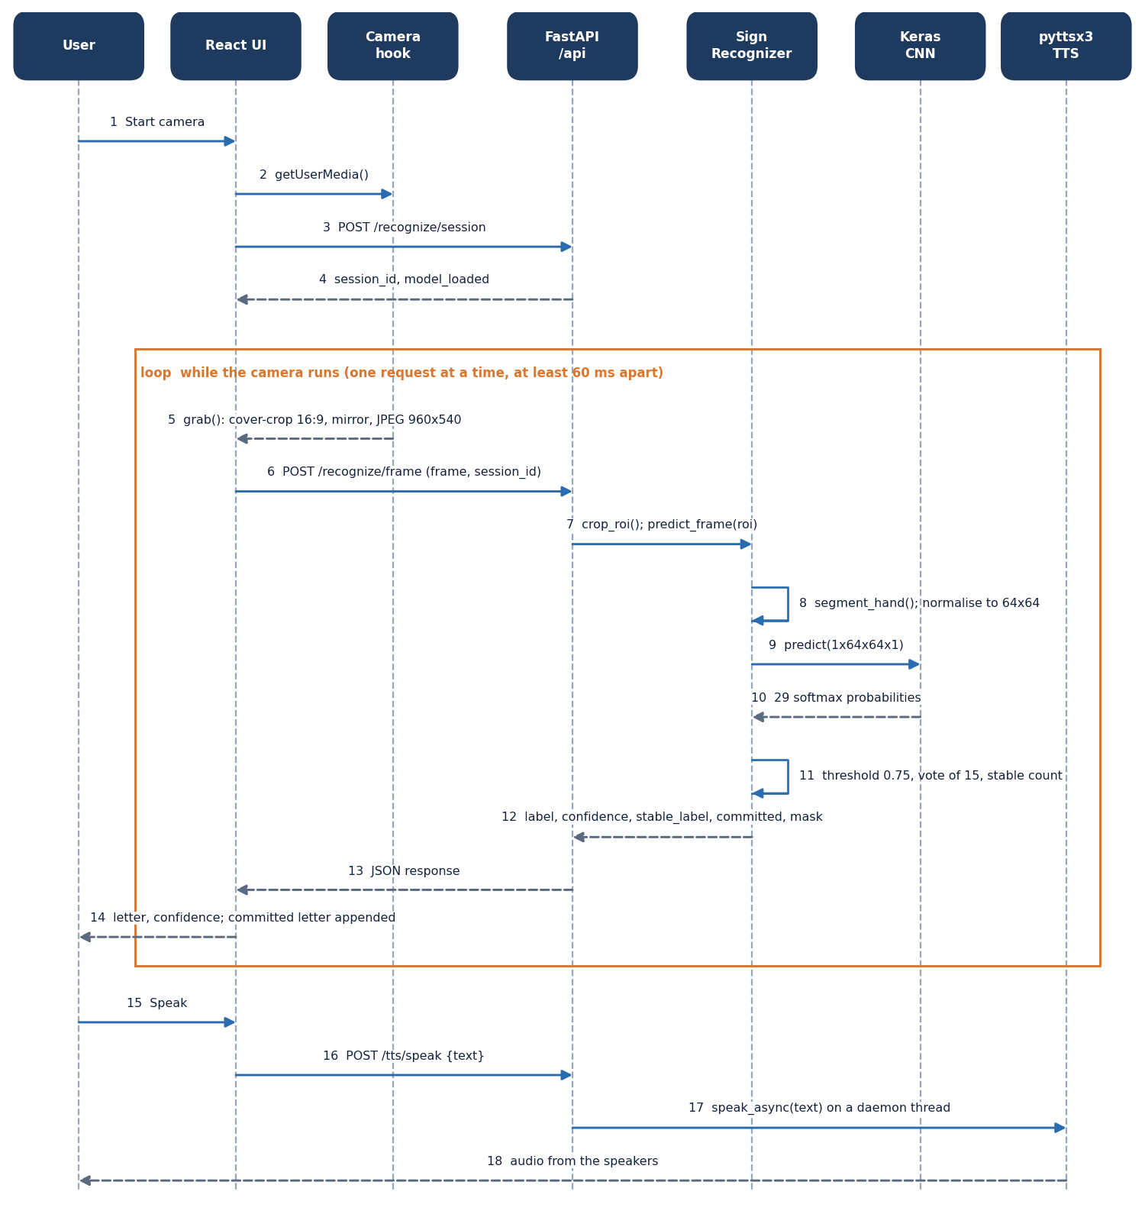
Figure 7: Sequence diagram of live recognition and speech.
The user starts the camera; the React page obtains the stream, opens a recognition session (steps 1-4) and then loops: grab a frame, post it, crop and preprocess it on the server, run the CNN, apply the threshold, vote and stable count, and return the result (steps 5-14). Only one request is in flight at a time and requests are at least 60 ms apart, so the loop cannot flood the server. Pressing Speak posts the sentence to /api/tts/speak, which starts the offline voice on a daemon thread (steps 15-18).

Use case diagram
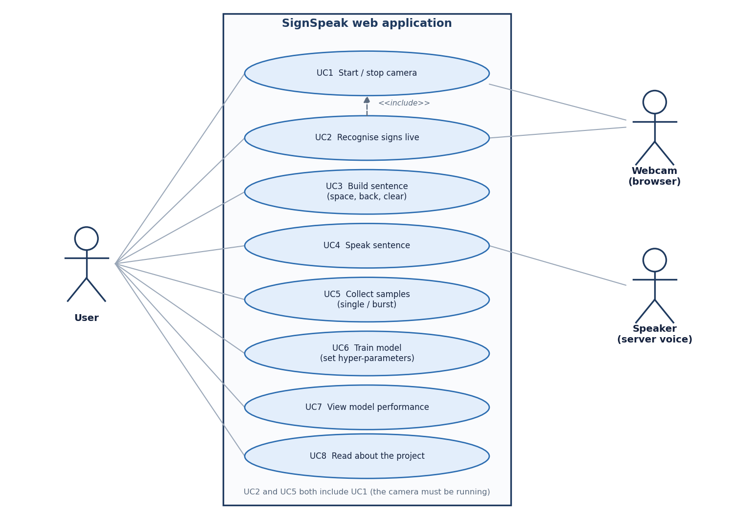
Figure 8: Use case diagram: eight use cases, one human actor and two system actors.
The user can start and stop the camera (UC1), recognise signs live (UC2), build a sentence with space, back and clear (UC3), speak it (UC4), collect samples singly or in bursts (UC5), train a model with chosen hyper-parameters (UC6), view model performance (UC7) and read about the project (UC8). UC2 and UC5 include UC1 because the camera must be running. The webcam (through the browser) and the speaker (the server voice) are the system actors. There are no accounts or roles.

Entity-relationship diagram (file store)
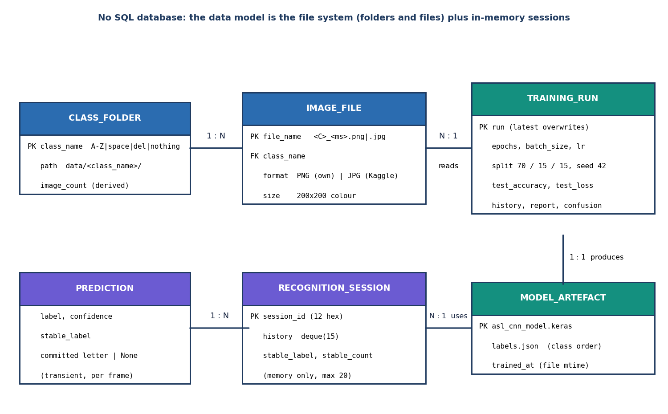
Figure 9: Entity-relationship diagram of the file-system data model; SignSpeak has no SQL database.
SignSpeak stores no records in a database. The data model is the file system: a class folder (one of 29) holds many image files; images are read by a training run; a run produces one model artefact (the Keras file, labels.json and the reports); a recognition session, kept only in memory, uses the model artefact and yields transient per-frame predictions. The diagram is drawn in entity-relationship style so that the relationships are explicit, but every PK is a file or folder name rather than a table key.

Flowchart of the core algorithm
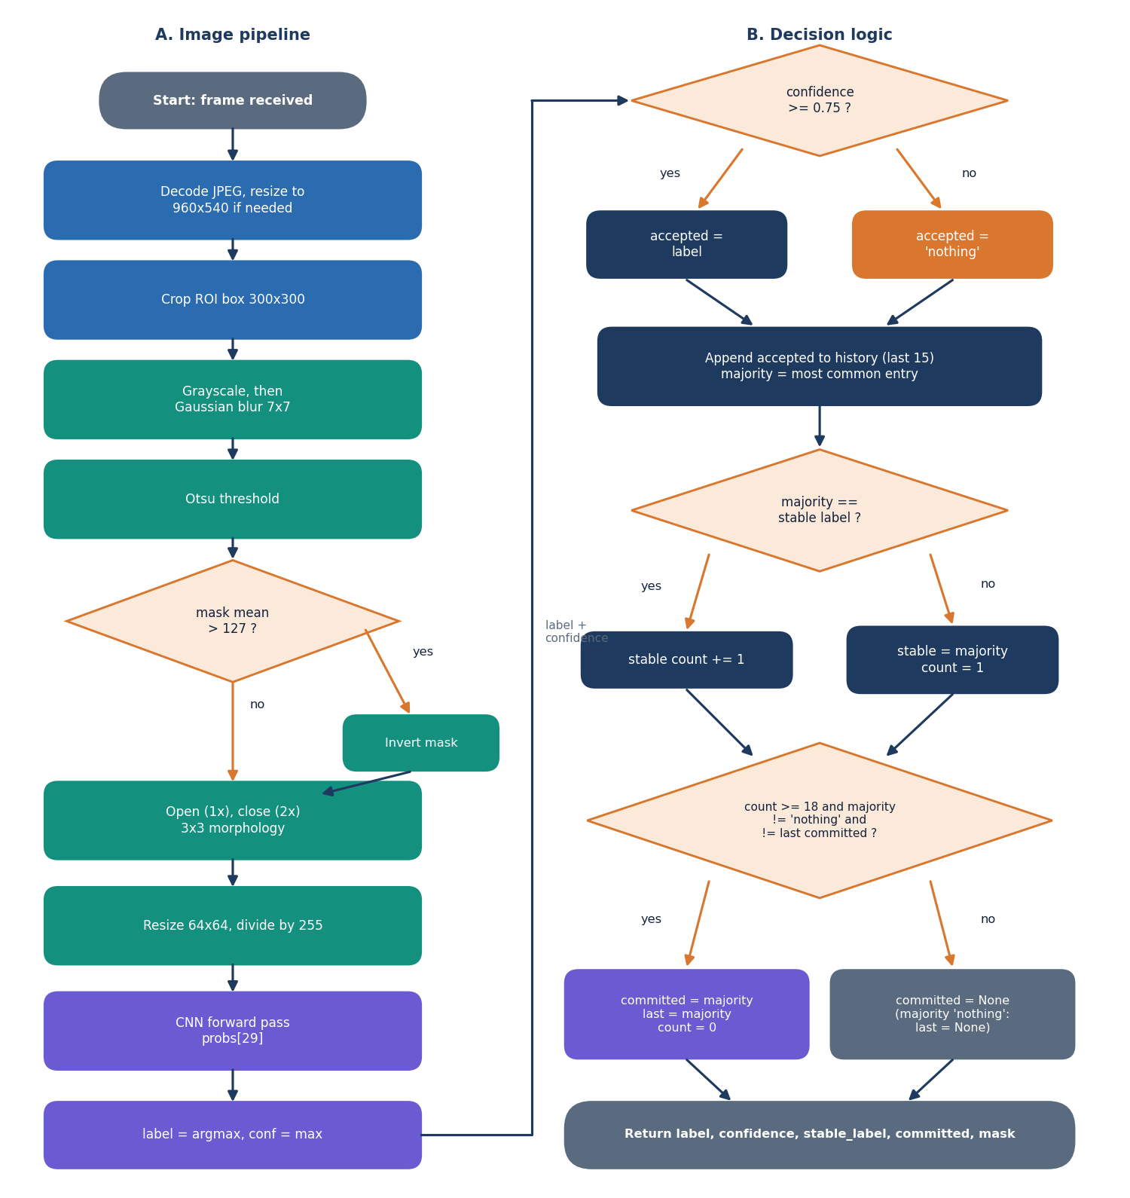
Figure 10: Flowchart of the core algorithm: (A) image pipeline and (B) decision logic.
Part A is the image pipeline: decode, crop, grayscale and blur, Otsu threshold, inversion when more than half the mask is white, morphological opening and closing, resize to 64x64, scaling and the CNN forward pass. Part B is the decision logic: a prediction below 0.75 confidence is replaced by nothing; the result joins a history of the last 15; the majority label is compared with the stable label and a counter is kept; a letter is committed when the counter reaches 18, the majority is not nothing and it differs from the last committed letter. A majority of nothing re-arms the repeat guard so that the same letter can be typed twice after the hand has been lowered.

CNN architecture
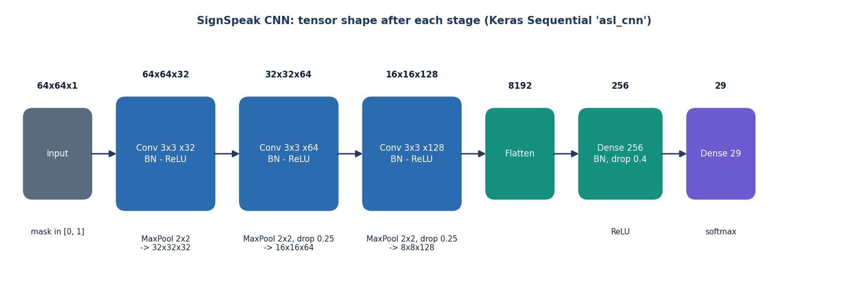
Figure 11: CNN architecture: three convolution blocks and a dense head (2,199,453 parameters).
The network takes a 64x64x1 mask. Block 1 is a 3x3 convolution with 32 filters, batch normalisation and 2x2 max pooling; block 2 doubles the filters to 64 and adds dropout 0.25; block 3 uses 128 filters with dropout 0.25. The 8x8x128 map is flattened to 8,192 values, passed through a dense layer of 256 units with batch normalisation and dropout 0.4, and a softmax layer of 29 units.

Training pipeline
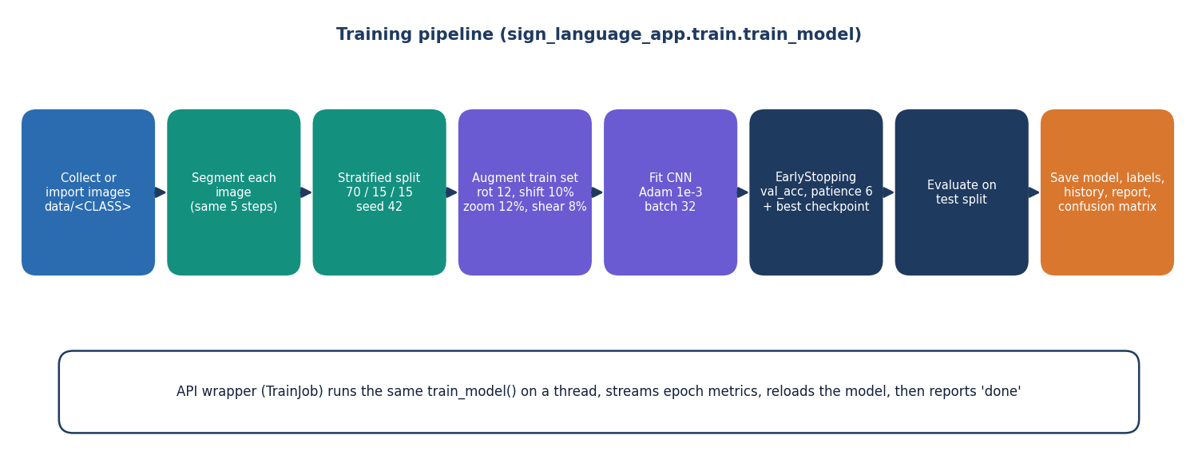
Figure 12: Training pipeline: load and preprocess, split, augment, fit with early stopping, evaluate, save.
All images in data/ are preprocessed once and cached in memory, then split 70/15/15 with a stratified split and seed 42. The training set is augmented on the fly (rotation 12 degrees, shifts 10 %, zoom 12 %, shear 8 %). Adam with learning rate 1e-3 minimises categorical cross-entropy; early stopping watches validation accuracy (patience 6, best weights restored) and the best model is checkpointed. After training the held-out test split gives the accuracy, the classification report and the confusion matrix, which are written next to the model.

